LAB 5

Example 5.1: Program demonstrates the passing of an array as a parameter to the function.

**package** Practice;

**public** **class** EX5_1 {

//method to print an, array, taking array as an arguments

**private** **static** **void** printArray(Integer[] intArray) {

System.***out***.println("Array contents printed through method");

//print individual elements of array using enhanced for loop

**for**(**int** val: intArray) {

System.***out***.print(val + " ");

}

}

**public** **static** **void** main(String[] args) {

//Integer array

Integer[] intArray = { 10, 20 , 30 , 40, 50 , 60, 70 ,80};

//call printArray method by passing intArray as an argument

*printArray*(intArray);

}

}

OUTPUT

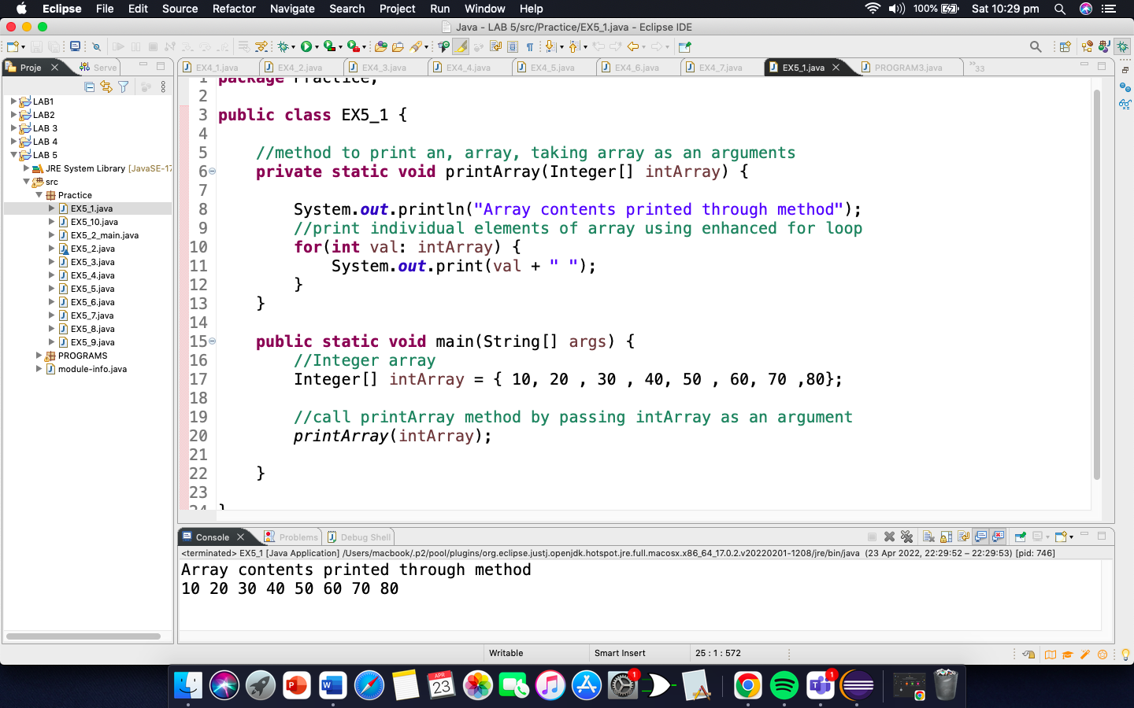

Example 5.2: Program that has function find_max()which can find the max value from the given array.

**package** Practice;

**class** EX5_2 {

**public** **int** find_max(**int**[] myArray) {

**int** max_val = 0;

//traverse the array to compare each element with max_val

**for** (**int** i=0; i<myArray.length; i++) {

**if**(max_val<myArray[i]) {

max_val = myArray[i];

}

}

//return max_val

**return** max_val;

}

}

MAIN

**package** Practice;

**import** java.util.Arrays;

**public** **class** EX5_2_main {

**public** **static** **void** main(String[] args) {

//input array

**int**[] myArray = {43, 54, 23, 65, 78, 85, 88, 92, 10};

System.***out***.println("Input Array: " + Arrays.*toString*(myArray));

//create object of class which has method to find maximum

EX5_2 obj = **new** EX5_2();

//pass input array to find_max method that returns maximum element

System.***out***.println("Maximum value in the given array is::" + obj.find_max(myArray));

}

}

OUTPUT

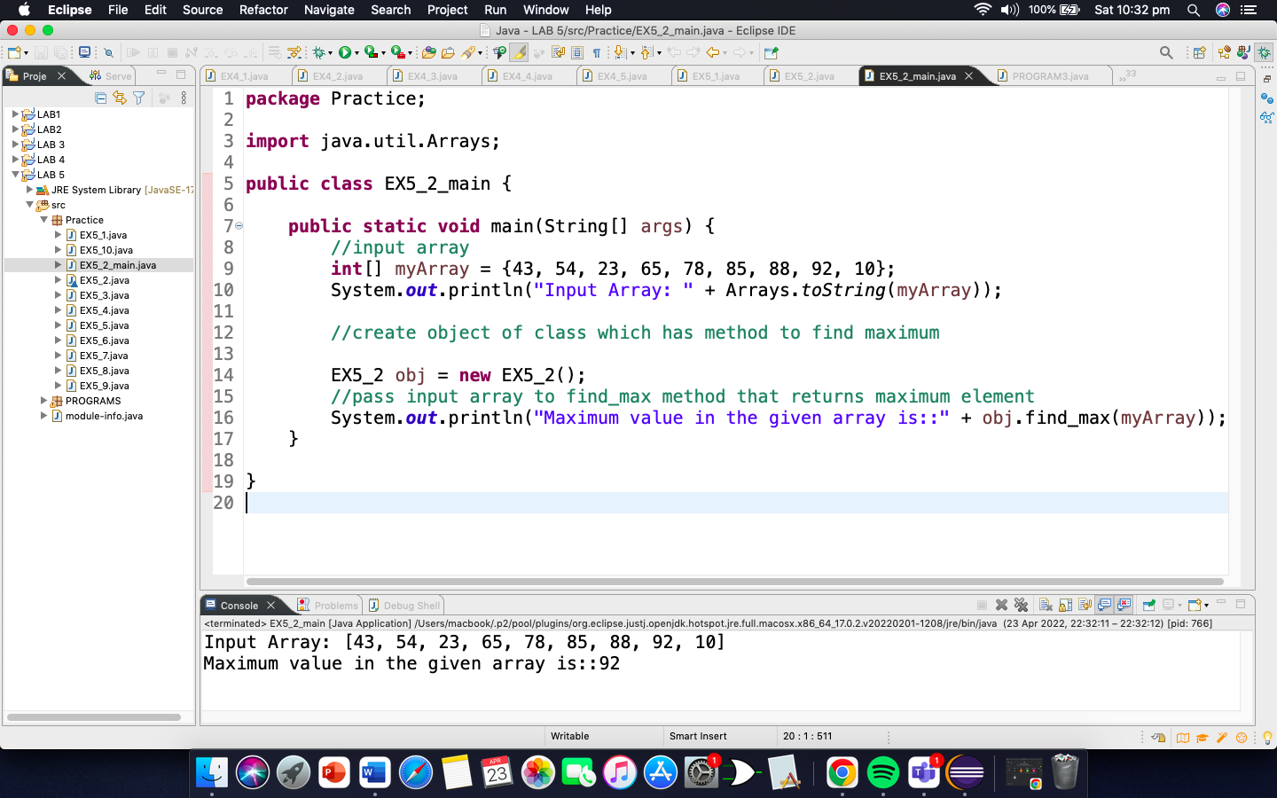

Example 5.3: Program returns a string array from a method.

**package** Practice;

**import** java.util.*;

**public** **class** EX5_3 {

**public** **static** String[] return_Array() {

//define string array

String[] ret_Array = {"Java", "C++", "Python", "Ruby", "C"};

//return string array

**return** ret_Array;

}

**public** **static** **void** main(String[] args) {

//call method return_array that returns array

String[] str_Array = *return_Array*();

System.***out***.println("Array returned from method: " + Arrays.*toString*(str_Array));

}

}

OUTPUT

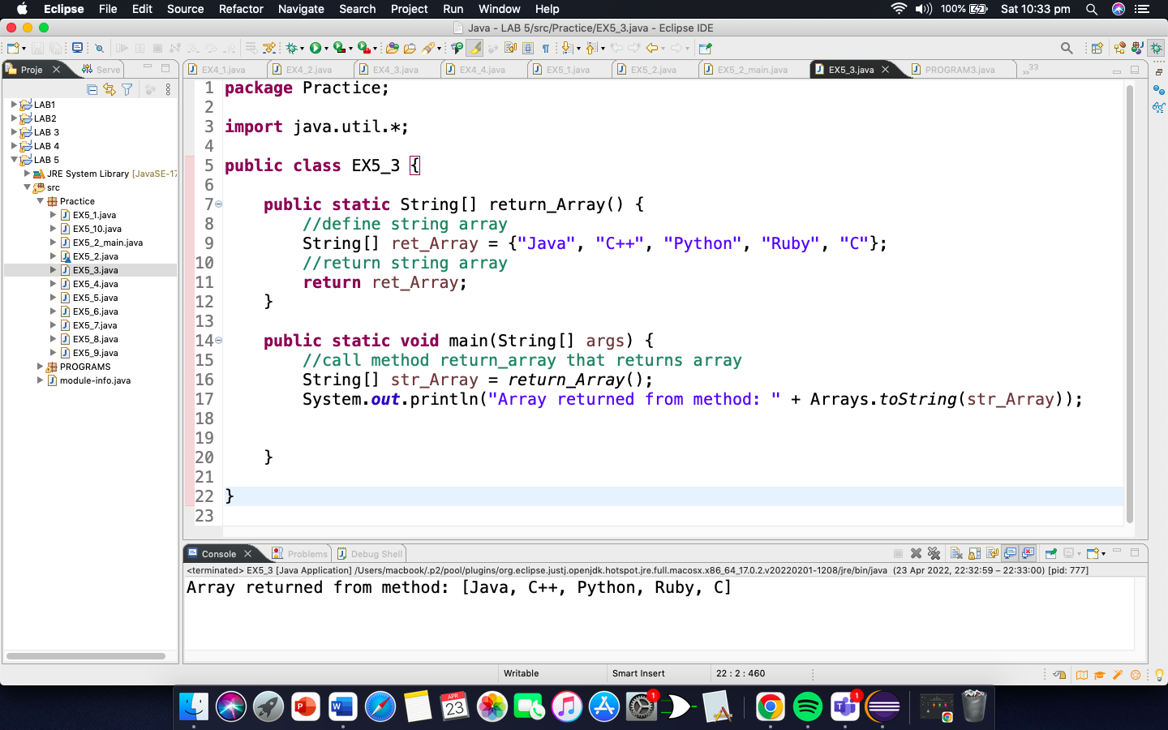

Example 5.4: Program that has an array having random elements, using a function.

**package** Practice;

**public** **class** EX5_4 {

**public** **static** **void** main(String[] args) {

**final** **int** N = 10; // number of random elements

// Create an array

**int**[] random_numbers;

// call create_random method that returns an array of random numbers

random_numbers = *create_random*(N);

System.***out***.println("The array of random numbers: ");

// display array of random numbers

**for** (**int** i=0; i<random_numbers.length ; i++) {

System.***out***.print(random_numbers[i] + " ");

}

}

**public** **static** **int**[] create_random(**int** N) {

//Create an array of size N => number of random numbers to be generated

**int**[] random_array = **new** **int**[N];

//generate random numbers and assign to array

**for**(**int** i=0; i<random_array.length; i++) {

random_array[i] = (**int**) (Math.*random*() * 10);

}

//return array of random numbers

**return** random_array;

}

}

OUTPUT

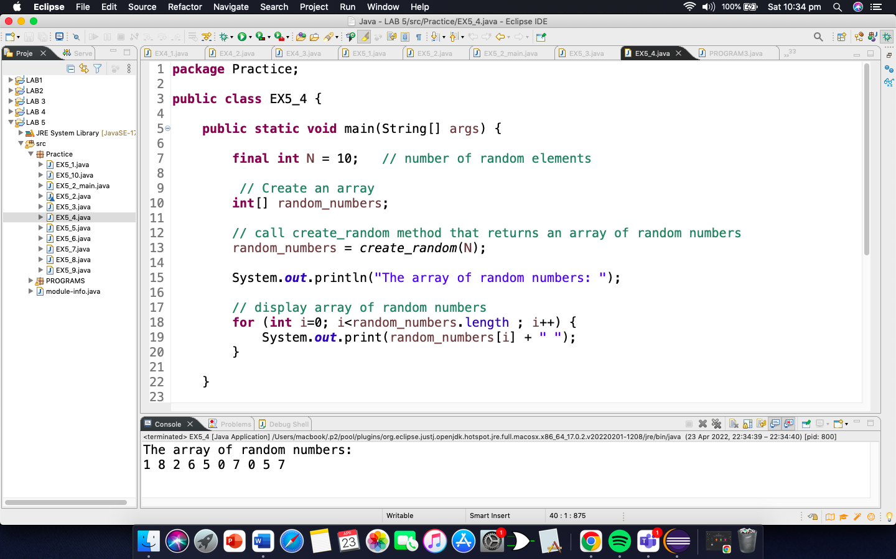

Example 5.5: Program that can help in searching a key element from an unsorted array.

**package** Practice;

**public** **class** EX5_5 {

// Function to implement search operation

**static** **int** findElement(**int** arr[], **int** n, **int** key) {

**for** (**int** i=0; i<n; i++) {

**if**(arr[i]==key)

**return** i;

}

**return** -1;

}

// Driver Code

**public** **static** **void** main(String[] args) {

**int**[] arr = {12, 34, 10, 6, 40};

**int** n = arr.length;

// Using a last element as search element

**int** key = 40;

**int** position = *findElement*(arr, n , key);

**if**(position == -1) {

System.***out***.println("Element not found");

}**else** {

System.***out***.println("Element found at position: " + (position + 1));

}

}

}

OUTPUT

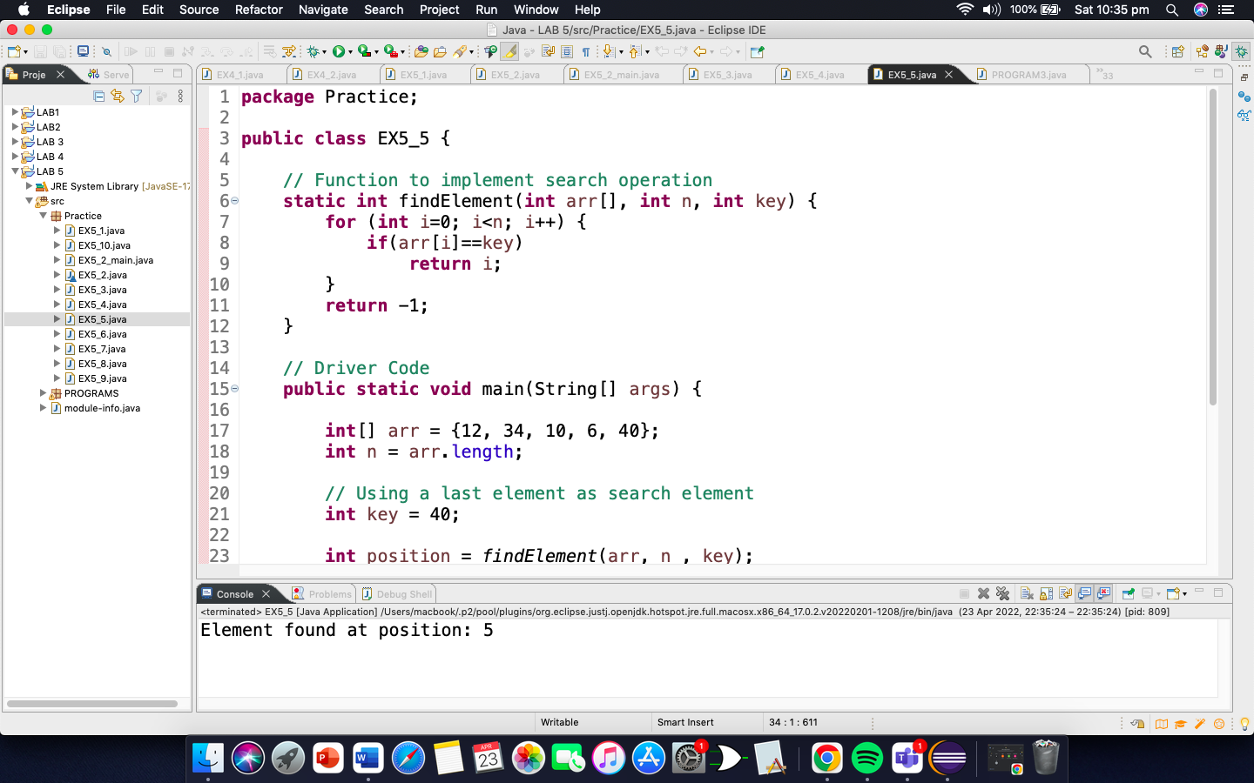

Example 5.6: Program to implement insert operation in an unsorted array.

**package** Practice;

**public** **class** EX5_6 {

// Function to insert a given key in the array. This function returns n+1

// if insertion is successful, else n.

**static** **int** insertSorted(**int** arr[], **int** n, **int** key, **int** capacity) {

// Cannot insert more elements if n is already more than or equal to

// capacity

**if**(n>=capacity) {

**return** n;

}

arr[n] = key;

**return** (n + 1);

}

// Driver Code

**public** **static** **void** main(String[] args) {

**int**[] arr = **new** **int**[20];

arr[0] = 12;

arr[1] = 16;

arr[2] = 20;

arr[3] = 40;

arr[4] = 50;

arr[5] = 70;

**int** capacity = 20;

**int** n = 6;

**int** key = 26;

System.***out***.println("Before Insertion");

**for**(**int** i=0; i<n; i++) {

System.***out***.print(arr[i] + " ");

}

// Inserting key

n = *insertSorted*(arr, n , key, capacity);

System.***out***.println("\nAfter Insertion");

**for**(**int** i = 0; i<n; i++) {

System.***out***.print(arr[i] + " ");

}

}

}

OUTPUT

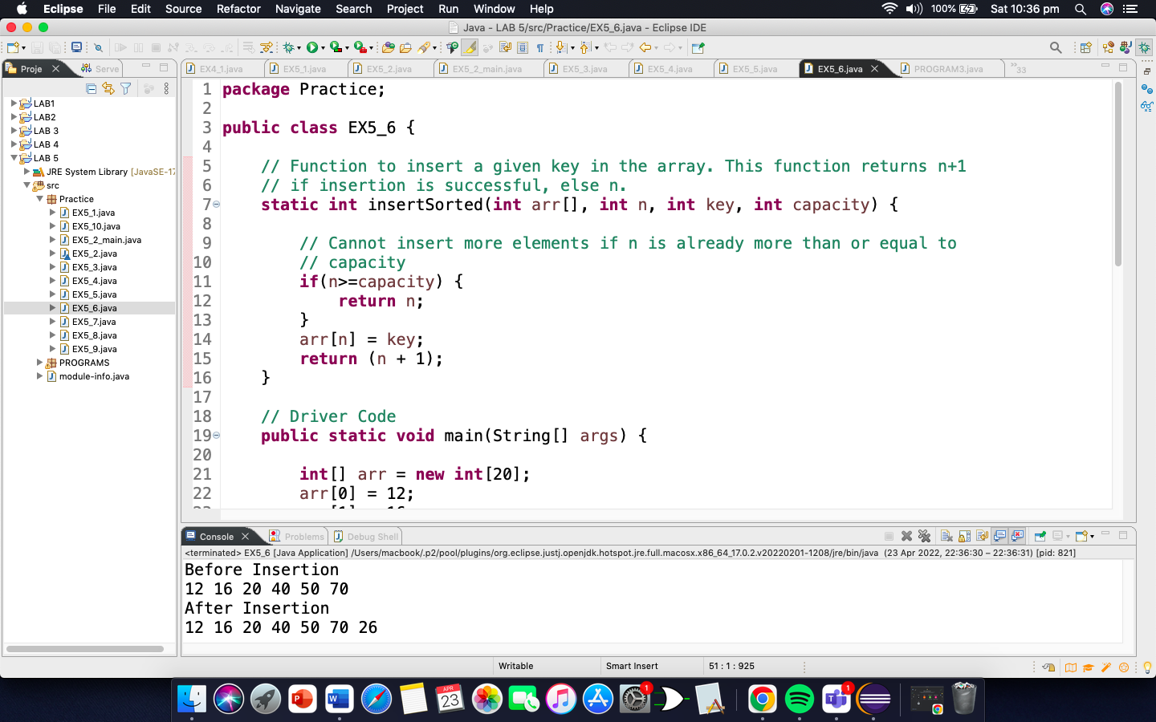

Example 5.7: Program to implement delete operation in an unsorted array.

**package** Practice;

**public** **class** EX5_7 {

// function to search a key to

// be deleted

**static** **int** findElement(**int** arr[], **int** n, **int** key) {

**for** (**int** i=0; i<n; i++) {

**if**(arr[i]==key)

**return** i;

}

**return** -1;

}

// Function to delete an element

**static** **int** deleteElement(**int** arr[], **int** n , **int** key) {

// Find position of element to be

// deleted

**int** pos = *findElement*(arr, n , key);

**if** (pos==-1) {

System.***out***.println("Element not found");

**return** n;

}

//deleting element

**for**(**int** i=pos; i<n-1 ; i++) {

arr[i] = arr[i+1];

}

**return** n - 1;

}

//driver code

**public** **static** **void** main(String[] args) {

**int** i;

**int** arr[] = {10, 50, 30, 40, 20};

**int** n = arr.length;

**int** key = 30;

System.***out***.println("Array before deletion");

**for**(i=0; i<n; i++) {

System.***out***.print(arr[i] + " ");

}

n = *deleteElement*(arr, n , key);

System.***out***.println("\n\nArray after deletion");

**for**(i=0; i<n; i++) {

System.***out***.print(arr[i] + " ");

}

}

}

OUTPUT

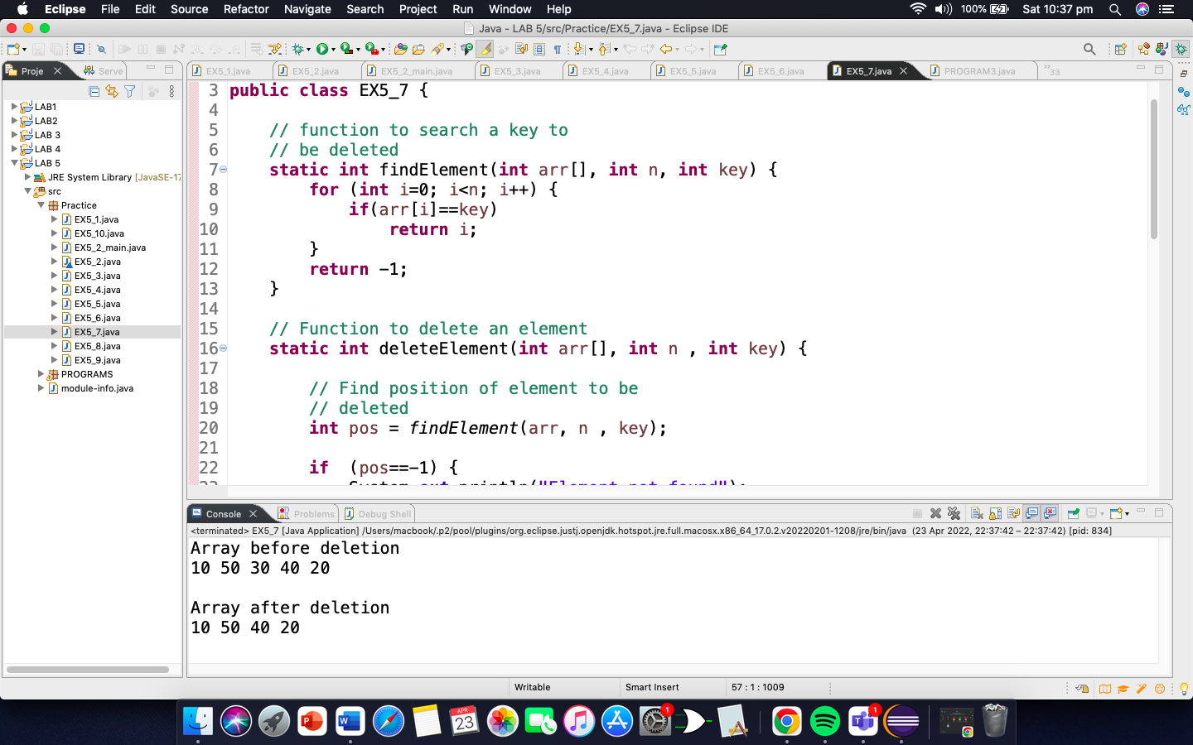

Example 5.8: Program to implement binary search in asorted array.

**package** Practice;

**public** **class** EX5_8 {

// function to implement

// binary search

**static** **int** binarySearch(**int** arr[], **int** low, **int** high, **int** key) {

**if**(high<low) {

**return** -1;

}

/*low + (high -low)/2;*/

**int** mid = (low + high)/2;

**if**(key==arr[mid]) {

**return** mid;

}

**if**(key > arr[mid]) {

**return** *binarySearch*(arr, (mid + 1), high, key);

}

**return** *binarySearch*(arr, low, (mid-1), key);

}

/* Driver Code*/

**public** **static** **void** main(String[] args) {

**int** arr[] = {5, 6, 7, 8, 9, 10};

**int** n, key;

n = arr.length-1;

key = 10;

System.***out***.println("Index: " + *binarySearch*(arr, 0, n, key));

}

}

OUTPUT

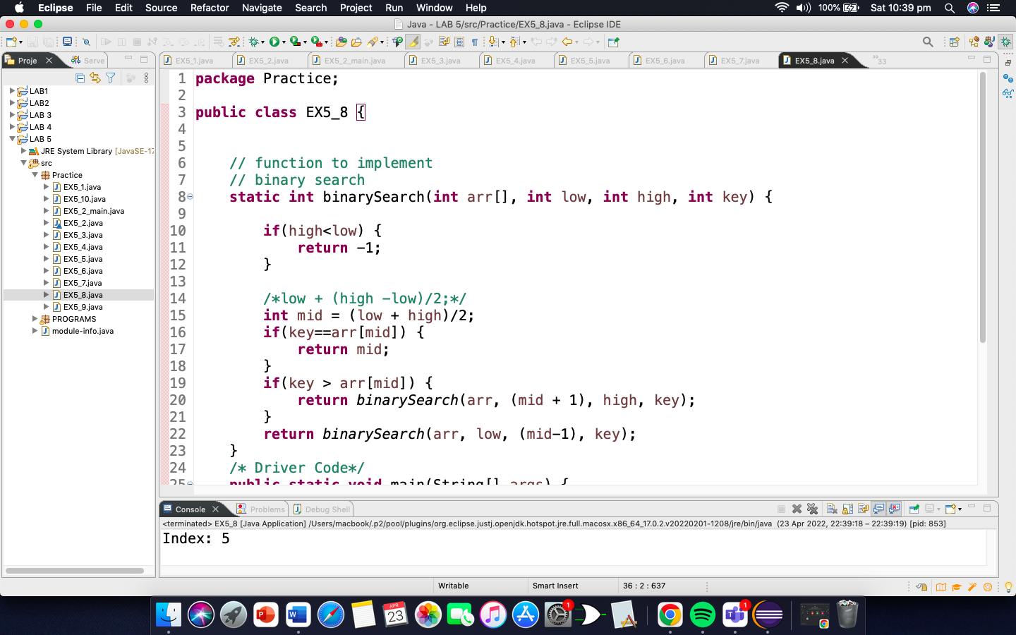

Example 5.9: Program to insert an element in a sorted array.

**package** Practice;

**public** **class** EX5_9 {

// Inserts a key in arr[] of given capacity. n is current size of arr[].

// This function returns n+1 if insertion is successful, else n.

**static** **int** insertSorted(**int** arr[], **int** n , **int** key, **int** capacity) {

// Cannot insert more elements if n is already

// more than or equal to capacity

**if**(n>=capacity) {

**return** n;

}

**int** i;

**for**(i=n-1; (i>=0 && arr[i]>key); i--) {

arr[i + 1] = arr[i];

}

arr[i+1] = key;

**return**(n + 1);

}

/* Driver program to test above function */

**public** **static** **void** main(String[] args){

**int** arr[] = **new** **int**[20];

arr[0] = 12;

arr[1] = 16;

arr[2] = 20;

arr[3] = 40;

arr[4] = 50;

arr[5] = 70;

**int** capacity = arr.length;

**int** n = 6;

**int** key = 26;

System.***out***.print("\nBefore Insertion: ");

**for**(**int** i=0; i<n; i++) {

System.***out***.print(arr[i] + " ");

}

//Inserting key

n = *insertSorted*(arr, n, key, capacity);

System.***out***.print("\nAfter Insertion: ");

**for**(**int** i=0; i<n; i++) {

System.***out***.print(arr[i] + " ");

}

}

}

OUTPUT

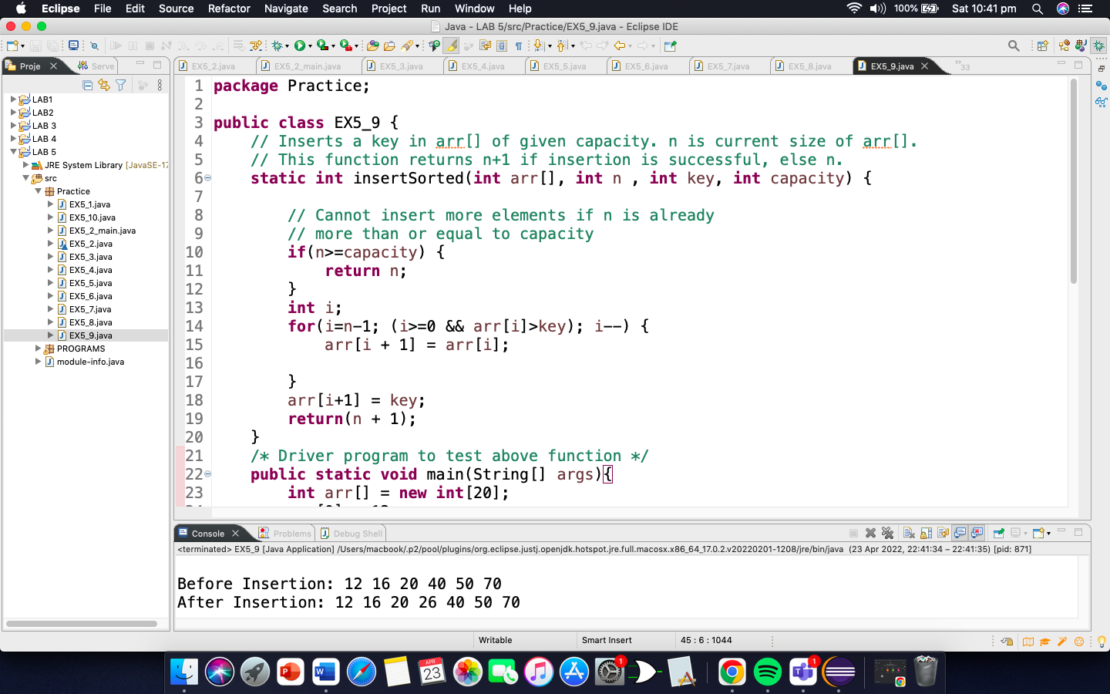

Example 5.10: Program to delete an element from a sorted array

**package** Practice;

**public** **class** EX5_10 {

//binary search

**static** **int** binarySearch(**int** arr[], **int** low, **int** high, **int** key) {

**if**(high<low) {

**return** -1;

}

/*low + (high -low)/2;*/

**int** mid = (low + high)/2;

**if**(key==arr[mid]) {

**return** mid;

}

**if**(key > arr[mid]) {

**return** *binarySearch*(arr, (mid + 1), high, key);

}

**return** *binarySearch*(arr, low, (mid-1), key);

}

/* Function to delete an element */

**static** **int** deleteElement(**int** arr[], **int** n , **int** key) {

// Find position of element to be

// deleted

**int** pos = *binarySearch*(arr, 0, n-1, key);

**if** (pos==-1) {

System.***out***.println("Element not found");

**return** n;

}

//deleting element

**for**(**int** i=pos; i<n-1 ; i++) {

arr[i] = arr[i+1];

}

**return** n - 1;

}

/* Driver Code*/

**public** **static** **void** main(String[] args) {

**int** i;

**int** arr[] = {10, 50, 30, 40, 20};

**int** n = arr.length;

**int** key = 30;

System.***out***.println("Array before deletion");

**for**(i=0; i<n; i++) {

System.***out***.print(arr[i] + " ");

}

n = *deleteElement*(arr, n , key);

System.***out***.println("\n\nArray after deletion");

**for**(i=0; i<n; i++) {

System.***out***.print(arr[i] + " ");

}

}

}

OUTPUT

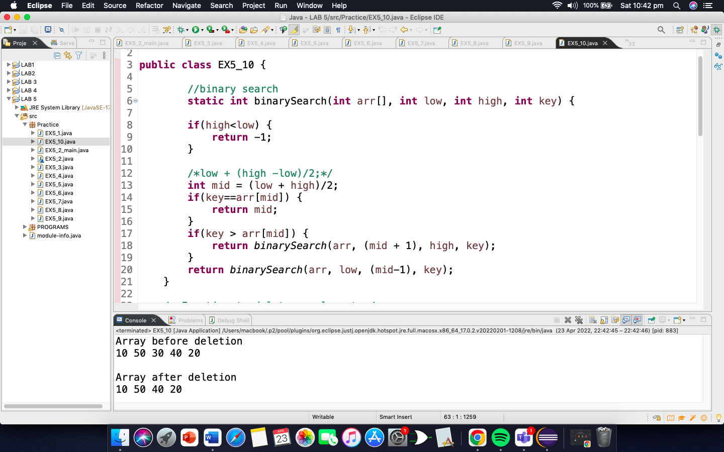

PROGRAMS

PROGRAM 1:

**package** PROGRAMS;

**import** java.util.Arrays;

**public** **class** PROGRAM1 {

**static** **int**[] Array(**int**[] arr1, **int**[] arr2, **int**[] arr3) {

**int** m = arr1.length;

**int** n = arr2.length;

arr3 = **new** **int**[m + n];

**int** i = 0;

**for**(**int** element: arr1) {

arr3[i] = element;

i++;

}

**for**(**int** element: arr2) {

arr3[i] = element;

i++;

}

System.***out***.println("----------Before sorting----------\n");

**for**(i=0; i<arr3.length; i++) {

System.***out***.print(arr3[i] + " ");

}

Arrays.*sort*(arr3);

System.***out***.println("\n\n----------After sorting----------\n");

**for**(i=0; i<arr3.length; i++) {

System.***out***.print(arr3[i] + " ");

}

**return** arr3;

}

**public** **static** **void** main(String[] args) {

**int**[] A = {1,2,3,4,5};

**int**[] B = {10,9,8,7,6};

**int**[] C = **new** **int**[A.length + B.length];

*Array*(A, B, C);

}

}

OUTPUT

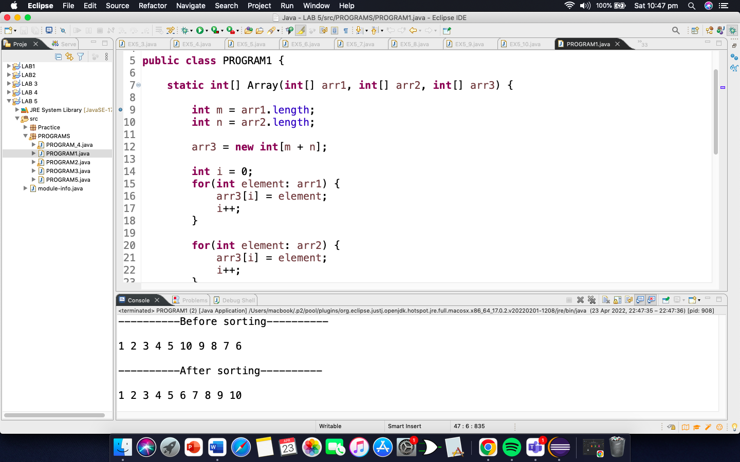

PROGRAM 2:

**package** PROGRAMS;

**import** java.util.Scanner;

**public** **class** PROGRAM2 {

**static** **int**[][] Array(**int**[][] arr1, **int** m , **int** n) {

**int**[][] arr2 = **new** **int**[m][n];

**for**(**int** i=0; i<arr2.length; i++) {

**for**(**int** j=0; j<arr2[i].length; j++) {

arr2[i][j] = arr1[i][j];

}

}

Scanner input = **new** Scanner(System.***in***);

System.***out***.println("Press 1 to display matrix\nPress 2 to display sum of each element in a matrix\nPress 3 to show row wise sum\nPress 4 to show column wise sum\nPress 5 to display transpose of matrix");

**int** number;

number = input.nextInt();

**if**(number==1) {

System.***out***.println("---------- Display of matrix ----------");

**for**(**int** i=0; i<arr2.length; i++) {

**for**(**int** j=0; j<arr2[i].length; j++) {

System.***out***.print(arr2[i][j] + " ");

}

System.***out***.println();

}

}

**if**(number==2) {

System.***out***.println("---------- Sum of matrix ----------");

**int** sum=0;

**for**(**int** i=0; i<arr2.length; i++) {

**for**(**int** j=0; j<arr2[i].length; j++) {

sum += arr2[i][j];

System.***out***.print(arr2[i][j] + " ");

}

System.***out***.println();

}

System.***out***.println("Sum of all elements in the given matrix is " + sum);

}

**if**(number==3) {

System.***out***.println("---------- Sum of row wise matrix ----------");

**for**(**int** i=0; i<arr2.length; i++) {

**for**(**int** j=0; j<arr2[i].length; j++) {

System.***out***.print(arr2[i][j] + " ");

}

System.***out***.println();

}

**for**(**int** i=0; i<arr2.length; i++) {

**int** sum=0;

**for**(**int** j=0; j<arr2[i].length; j++) {

sum += arr2[i][j];

}

System.***out***.println("The Sum " + (i + 1) + " row is " + sum);

}

}

**if**(number==4) {

System.***out***.println("---------- Sum of column wise matrix ----------");

**for**(**int** i=0; i<arr2.length; i++) {

**for**(**int** j=0; j<arr2[i].length; j++) {

System.***out***.print(arr2[i][j] + " ");

}

System.***out***.println();

}

**for**(**int** i=0; i<arr2.length; i++) {

**int** sum=0;

**for**(**int** j=0; j<arr2[i].length; j++) {

sum += arr2[j][i];

}

System.***out***.println("The Sum " + (i + 1) + " column is " + sum);

}

}

**if**(number==5) {

System.***out***.println("---------- Transpose of matrix ----------");

**for**(**int** i=0; i<arr2.length; i++) {

**for**(**int** j=0; j<arr2[i].length; j++) {

System.***out***.print(arr2[j][i] + " ");

}

System.***out***.println();

}

}

**return** arr2;

}

**public** **static** **void** main(String[] args) {

**int** A = 3;

**int** B = 3;

**int**[][] C = {{1,2,3},

{4,3,5},

{8,2,9}};

*Array*(C, A, B);

}

}

OUTPUT

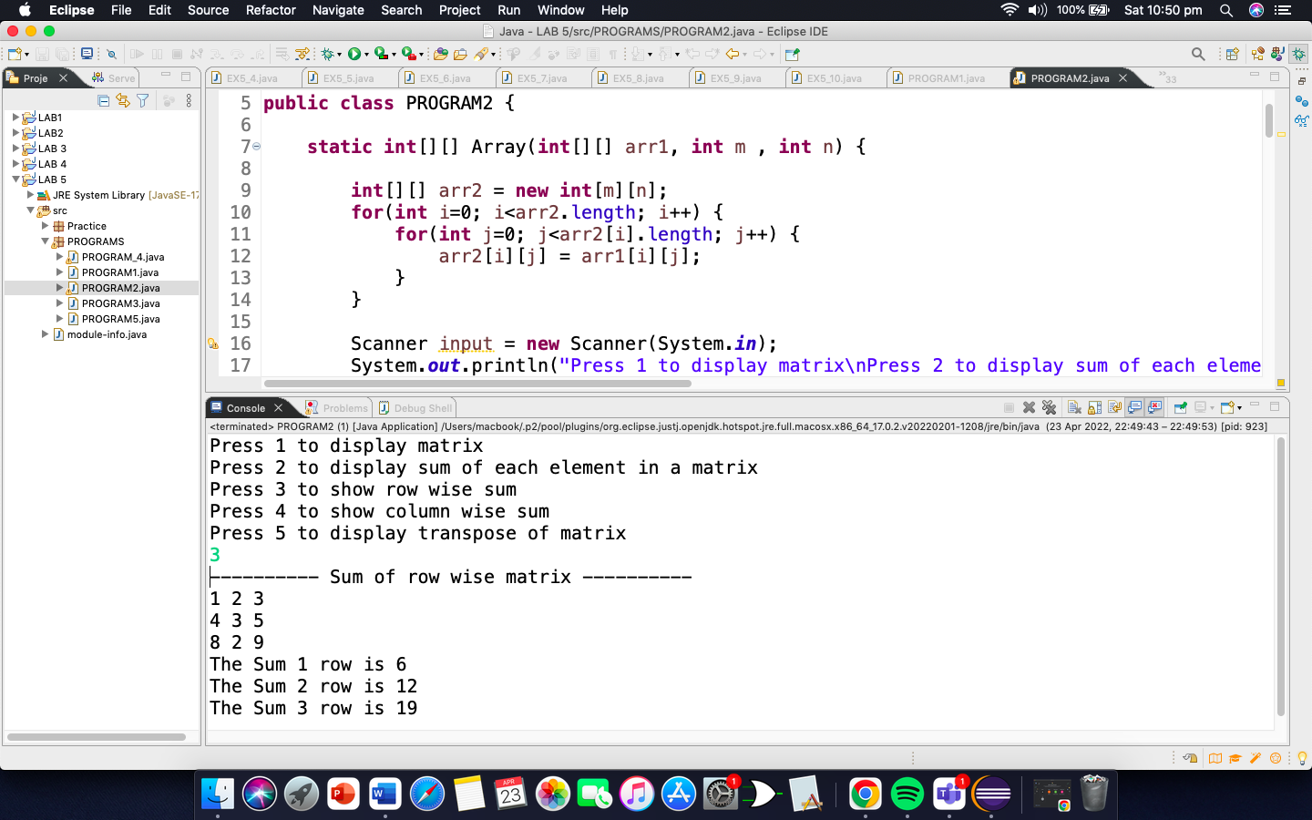

PROGRAM 3:

**package** PROGRAMS;

**public** **class** PROGRAM3 {

**static** **int**[][] Array(**int**[][] arr1, **int**[][] arr2){

//mask

System.***out***.println("Orignal Mask\n");

**for**(**int** i=0; i<arr1.length; i++) {

**for**(**int** j=0; j<arr1[i].length; j++) {

System.***out***.print(arr1[i][j] + " " );

}

System.***out***.println();

}

System.***out***.println("\n");

System.***out***.println("Horizontally flipped Mask\n");

//flipping the mask horizontally

**int**[][] C =**new** **int** [3][3];

**for**(**int** i=0; i<arr1.length; i++) {

**for**(**int** j=arr1[i].length-1; j>=0; j--) {

C[i][j] = arr1[i][arr1.length-1-j];

System.***out***.print(arr1[i][j] + " ");

}

System.***out***.println();

}

System.***out***.println("\n");

System.***out***.println("Vertically flipped Mask\n");

//flipping the mask vertically

**int**[][] E =**new** **int** [3][3];

**for**(**int** i=C.length-1; i>=0; i--) {

**for**(**int** j=0; j<C[i].length; j++) {

E[i][j] = C[arr1.length-1-i][j];

System.***out***.print(C[i][j] + " ");

}

System.***out***.println();

}

//padding of matrix

**int**[][] d =**new** **int**[arr2.length+2][arr2.length+2];

**for**(**int** i=0; i<E.length; i++) {

**for**(**int** j=0; j<E[i].length; j++) {

d[i+1][j+1] = E[i][j];

}

}

System.***out***.println("\nPadded matrix\n");

**for**(**int** i=0; i<d.length; i++) {

**for**(**int** j=0; j<d[i].length; j++) {

System.***out***.print(d[i][j] + " ");

}

System.***out***.println();

}

**int** sum=0;

**int**[][] f = **new** **int**[3][3];

**for**(**int** i=0; i<arr2.length; i++) {

**for**(**int** j=0; j<arr2[i].length; j++) {

f[i][j]=(arr2[i][j]*d[i][j]);

sum +=f[i][j];

arr2[0][0] = sum;

}

}

System.***out***.println("\nConvolution of first index\n");

**for**(**int** i=0; i<arr2.length; i++) {

**for**(**int** j=0; j<arr2[i].length; j++) {

System.***out***.print(arr2[i][j] + " " );

}

System.***out***.println();

}

**return** arr1;

}

**public** **static** **void** main(String[] args) {

**int**[][] A = {{1,2,3,},

{4,5,6},

{7,8,9}};

**int**[][] B = {{2,4,6},

{8,10,12},

{14,16,18}};

*Array*(A,B);

}

}

OUTPUT

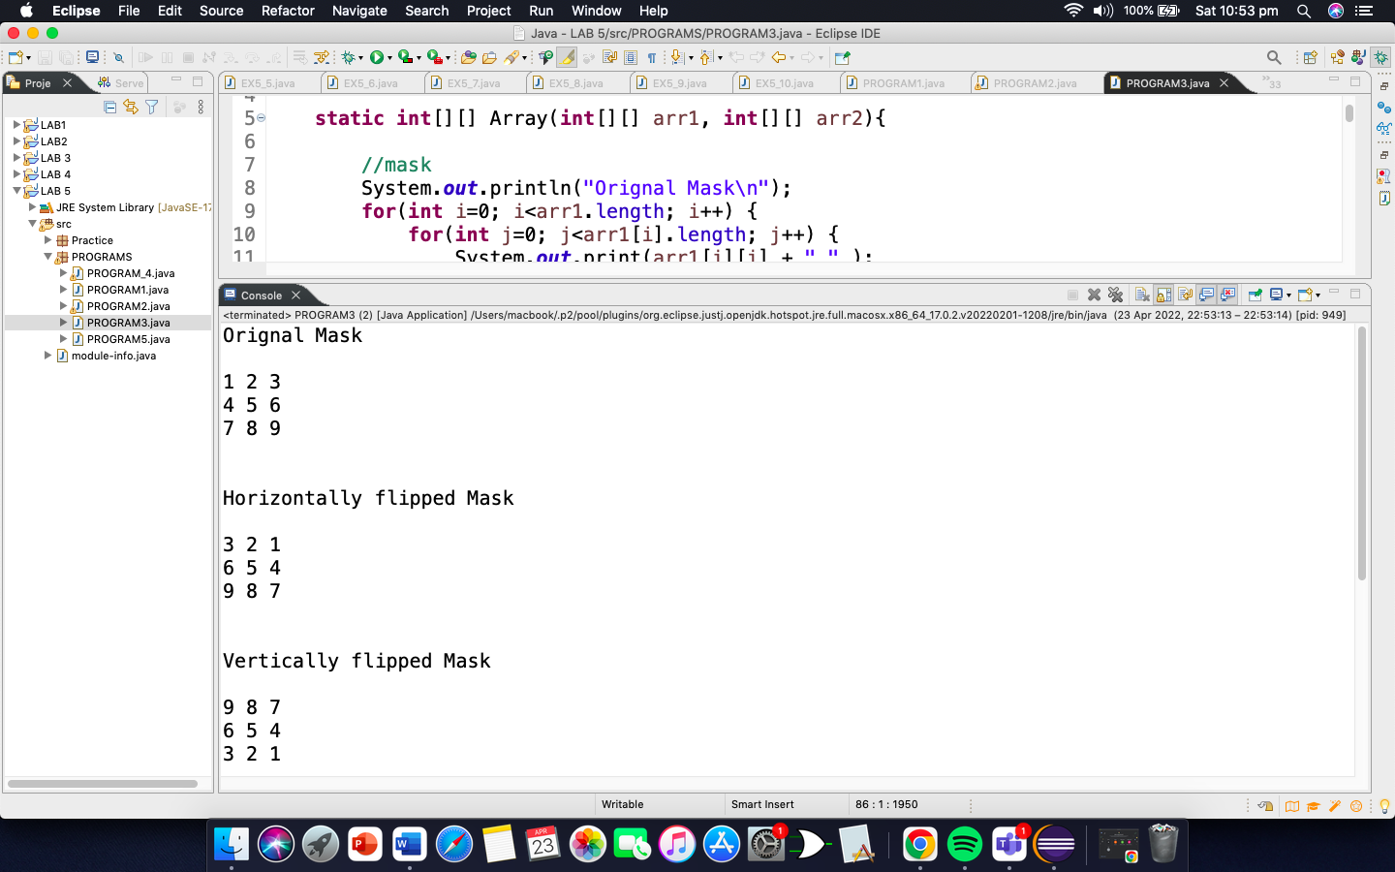

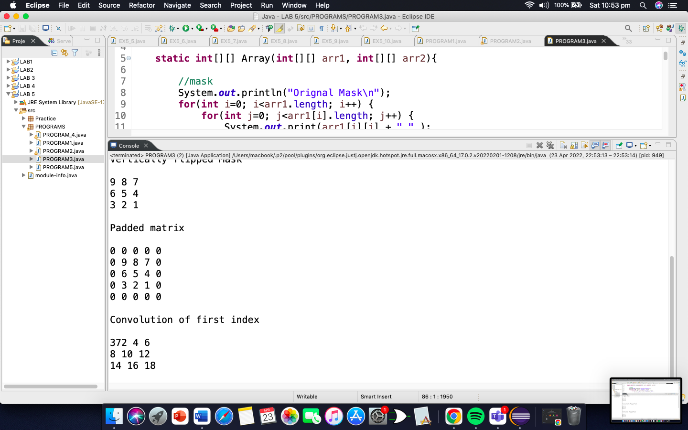

PROGRAM 4:

**package** PROGRAMS;

**import** java.util.Scanner;

**public** **class** PROGRAM_4 {

**static** **int**[] Array(**int**[] arr1, **int**[] arr2, **int**[] arr3, **int**[] arr4) {

String output = "Subject|\tNumbers|Histogram\n----------------------------------";

String[] subject = {"English", "Urdu", "Maths", "Science", "ICT"};

Scanner input = **new** Scanner(System.***in***);

System.***out***.println("Press 1 for Shaheer\nPress 2 for Sawera\nPress 3 for Sooraj\nPress 4 for Nida");

**int** number;

number = input.nextInt();

**if**(number==1) {

System.***out***.println("---------- Shaheer ----------\n");

**for** ( **int** i = 0; i < arr1.length; i++ ) {

output += "\n" + subject[i] + "\t\t" + arr1[ i ] + "\t";

**for** ( **int** stars = 0; stars < arr1[ i ]; stars++ ) {

output += "*";

}

}

System.***out***.println(output);

System.***out***.println("----------------------------------");

}

**if**(number==2) {

System.***out***.println("---------- Sawera ----------\n");

**for** ( **int** i = 0; i < arr2.length; i++ ) {

output += "\n" + subject[i] + "\t\t" + arr2[ i ] + "\t";

**for** ( **int** stars = 0; stars < arr2[ i ]; stars++ ) {

output += "*";

}

}

System.***out***.println(output);

System.***out***.println("----------------------------------");

}

**if**(number==3) {

System.***out***.println("---------- Sooraj ----------\n");

**for** ( **int** i = 0; i < arr3.length; i++ ) {

output += "\n" + subject[i] + "\t\t" + arr3[ i ] + "\t";

**for** ( **int** stars = 0; stars < arr3[ i ]; stars++ ) {

output += "*";

}

}

System.***out***.println(output);

System.***out***.println("----------------------------------");

}

**if**(number==4) {

System.***out***.println("---------- Nida ----------\n");

**for** ( **int** i = 0; i < arr4.length; i++ ) {

output += "\n" + subject[i] + "\t\t" + arr4[ i ] + "\t";

**for** ( **int** stars = 0; stars < arr4[ i ]; stars++ ) {

output += "*";

}

}

System.***out***.println(output);

System.***out***.println("----------------------------------");

}

**return** arr1;

}

**public** **static** **void** main(String[] args) {

**int**[] arr1 = {8,7,8,7,9};

**int**[] arr2 = {8,8,5,5,8};

**int**[] arr3 = {7,9,9,7,10};

**int**[] arr4 = {7,8,7,6,9};

*Array*(arr1,arr2,arr3,arr4);

}

}

OUTPUT

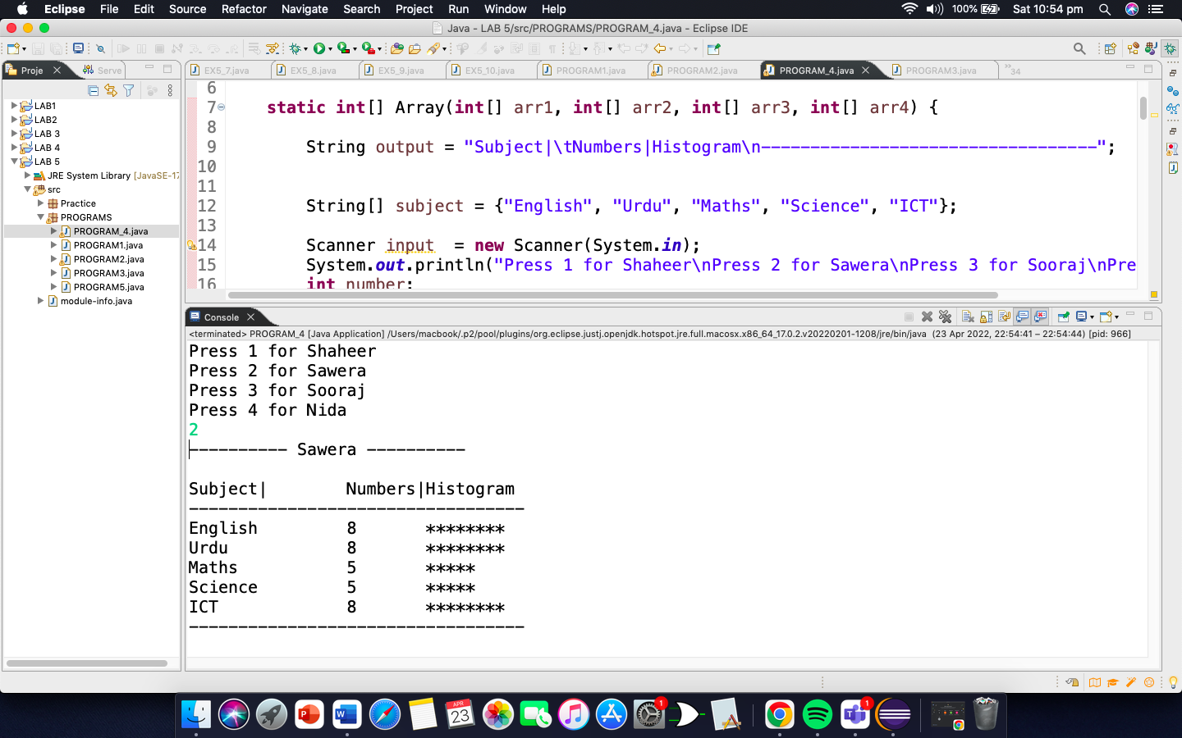

PROGRAM 5:

**package** PROGRAMS;

**public** **class** PROGRAM5 {

**static** **int**[] Array(**int**[] arr1, **int**[] arr2, **int**[] arr3) {

System.***out***.println("Welcome to the grade book");

System.***out***.println("CS211DATA STRUCTURES & ALGORITHMS\n");

System.***out***.println("The grades are:\n");

String output = "Student|\tTest1|\t\tTest2|\t\tTest3|\t\tAverage|\n------------------------------------------------------------------------";

String[] name = {"Shaheer", "Sawera", "Sooraj", "Huzaifa", "Zahir", "Nida", "Aariz", "Hassan", "Areeb", "Shazim"};

**int** max = 0;

**int** min = arr1[0];

**for**(**int** i=0; i<arr1.length; i++) {

**float** d = ((arr1[i] + arr2[i] + arr3[i])*100)/300;

output += "\n" + name[i] + "\t\t" + arr1[ i ] + "\t\t" + arr2[ i ] + "\t\t" + arr3[ i ] + "\t\t" + d;

**if**(max<=arr1[i]) {

max=arr1[i];

}

**if**(max<=arr2[i]) {

max=arr2[i];

}

**if**(max<=arr3[i]) {

max=arr3[i];

}

**if**(min>arr1[i] ) {

min=arr1[i];

}

**if**(min>arr2[i]) {

min=arr2[i];

}

**if**(min>arr3[i]) {

min=arr3[i];

}

}

System.***out***.println(output);

System.***out***.println("\nHighest grade in the grade book is " + max);

System.***out***.println("Lowest grade in the grade book is " + min + "\n");

**float**[] Average = **new** **float**[10];

**for**(**int** i=0; i<Average.length; i++) {

**float** d = ((arr1[i] + arr2[i] + arr3[i])*100)/300;

Average[i] = d;

}

**int** counter = 0,counter2 = 0,counter3 = 0,counter4 = 0,counter5 = 0,counter6 = 0,counter7 = 0,counter8 = 0,counter9 = 0,counter10= 0;

**int**[] C = **new** **int**[10];

**for**(**int** i=0; i<Average.length; i++) {

**if**(Average[i]>=0&&Average[i]<=10) {

counter++;

}

**else** **if**(Average[i]>10&&Average[i]<=20) {

counter2++;

}

**else** **if**(Average[i]>20&&Average[i]<=30) {

counter3++;

}

**else** **if**(Average[i]>30&&Average[i]<=40) {

counter4++;

}

**else** **if**(Average[i]>40&&Average[i]<=50) {

counter5++;

}

**else** **if**(Average[i]>50&&Average[i]<=60) {

counter6++;

}

**else** **if**(Average[i]>60&&Average[i]<=70) {

counter7++;

}

**else** **if**(Average[i]>70&&Average[i]<=80) {

counter8++;

}

**else** **if**(Average[i]>80&&Average[i]<=90) {

counter9++;

}

**else** **if**(Average[i]>90&&Average[i]<=100) {

counter10++;

}

**int**[] numbers = {counter,counter2,counter3,counter4,counter5,counter6,counter7,counter8,counter9,counter10};

**for**(**int** j =0; j<C.length; j++) {

C[j] = numbers[j];

}

}

System.***out***.println("Overall grade distribution:");

**int**[] scores ={0,10,20,30,40,50,60,70,80,90};

**int**[] scores2 = {10,19,29,39,49,59,69,79,89,100};

String A="";

**for**(**int** i=0;i<scores.length; i++) {

A += "\n" + scores[i] +"-"+ scores2[i] + ":" + "\t";

**for** ( **int** stars = 0; stars < C[ i ]; stars++ ) {

A += "*";

}

}

System.***out***.println(A);

**return** arr1;

}

**public** **static** **void** main(String[] args) {

**int**[] A = {86,68,94,100,83,78,85,91,76,87};

**int**[] B = {96,87,100,81,65,87,75,94,72,93};

**int**[] C = {70,90,90,82,85,65,83,100,84,73};

*Array*(A, B, C);

}

}

OUTPUT

